**Practical 7: - Write a program for web feed.**

sudo gedit /var/www/html/rss.html

sudo gedit /var/www/html/getrss.php

**rss.html**

<html>

<head>

<script>

function showRSS(str) {

if (str.length == 0) {

document.getElementById("output").innerHTML = "";

return;

}

if (window.XMLHttpRequest) {

xmlhttp = new XMLHttpRequest();

}else {

xmlhttp = new ActiveXObject("Microsoft.XMLHTTP");

}

xmlhttp.onreadystatechange = function() {

if (xmlhttp.readyState == 4 && xmlhttp.status == 200) {

document.getElementById("output").innerHTML = xmlhttp.responseText;

}

}

xmlhttp.open("GET","getrss.php?q="+str,true);

xmlhttp.send();

}

</script>

</head>

<body>

<p>Please Select an option to get RSS:</p>

<form>

<select onchange = "showRSS(this.value)">

<option value = "">Select an RSS-feed:</option>

<option value = "cnn">CNN</option>

<option value = "Google News">Google News</option>

<option value = "pc">PC World</option>

</select>

</form>

<br>

<div id = "output">RSS-feeds</div>

</body>

</html>

**getrss.php**

<?php

$q = $_GET["q"];

if($q == "cnn") {

$xml = ("http://rss.cnn.com/rss/cnn_topstories.rss");

}elseif($q == "Google News") {

$xml = ("https://news.google.com/news/rss");

}elseif($q = "pcw"){

$xml = ("http://www.pcworld.com/index.rss");

}

$xmlDoc = new DOMDocument();

$xmlDoc->load($xml);

$channel = $xmlDoc->getElementsByTagName('channel')->item(0);

$channel_title = $channel->getElementsByTagName('title')

->item(0)->childNodes->item(0)->nodeValue;

$channel_link = $channel->getElementsByTagName('link')

->item(0)->childNodes->item(0)->nodeValue;

$channel_desc = $channel->getElementsByTagName('description')

->item(0)->childNodes->item(0)->nodeValue;

echo("<p><a href = '" . $channel_link . "'>" .

$channel_title . "</a>");

echo("<br>");

echo($channel_desc . "</p>");

$x = $xmlDoc->getElementsByTagName('item');

for ($i = 0; $i<=2; $i++) {

$item_title = $x->item($i)->getElementsByTagName('title')

->item(0)->childNodes->item(0)->nodeValue;

$item_link = $x->item($i)->getElementsByTagName('link')

->item(0)->childNodes->item(0)->nodeValue;

$item_desc = $x->item($i)->getElementsByTagName('description')

->item(0)->childNodes->item(0)->nodeValue;

echo ("<p><a href = '" . $item_link . "'>" .

$item_title . "</a>");

echo ("<br>");

echo ($item_desc . "</p>");

}

?>

**Output:-**

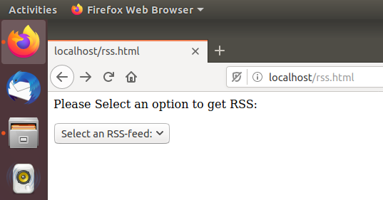

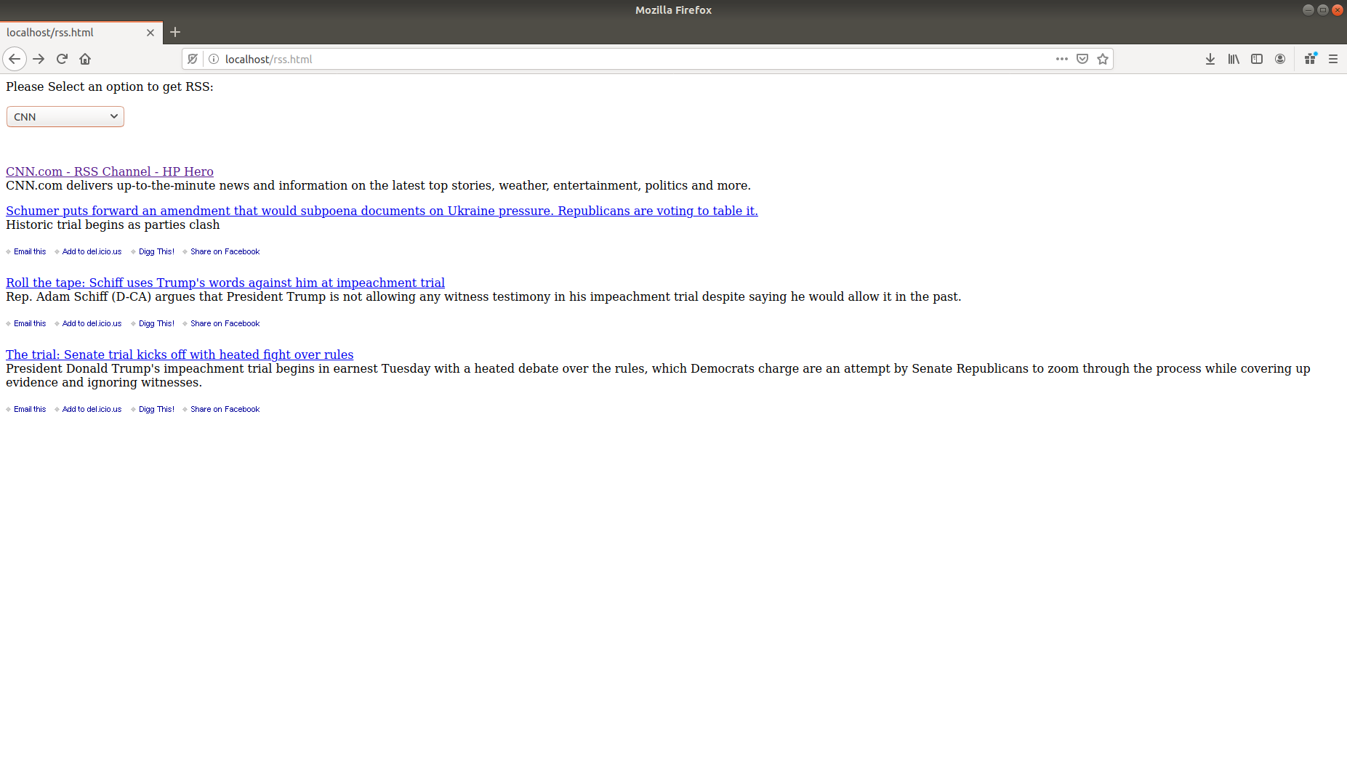

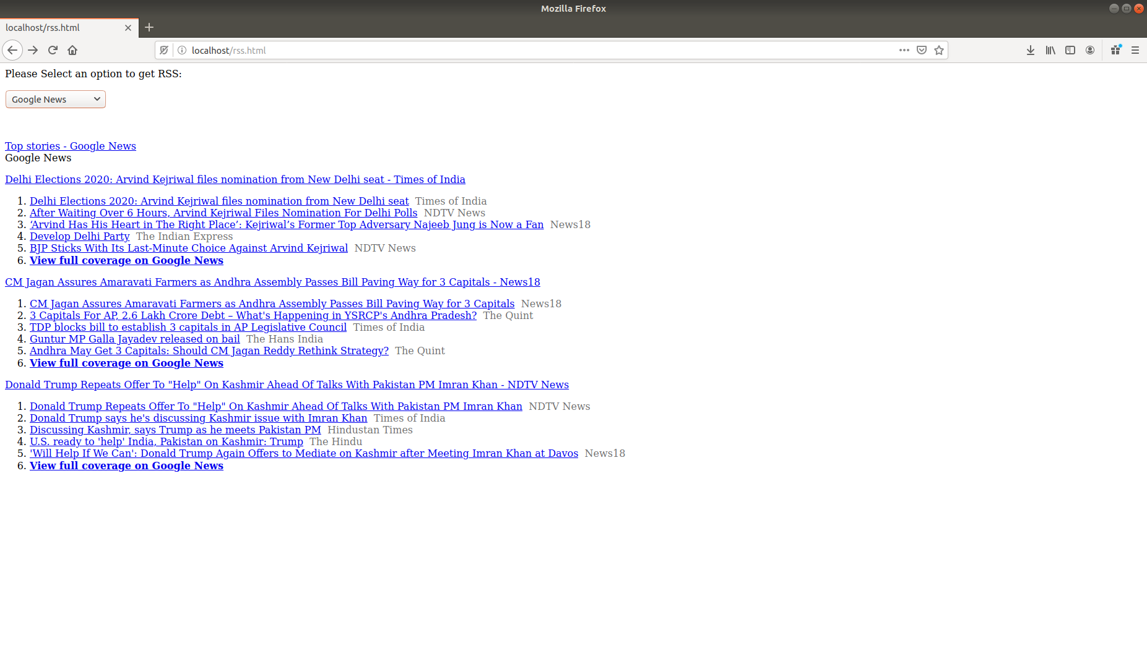

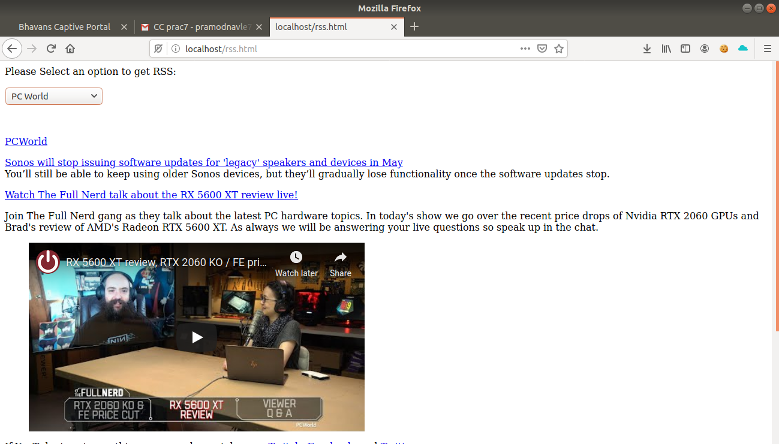----------------------------------------------------------------------------------------------------------------------------------

**#PHP ERROR**

sudo apt-get install software-properties-common

sudo add-apt-repository ppa:ondrej/php

sudo apt-get install php7.1 libapache2-mod-php7.1 php7.1-mcrypt php7.1-cli php7.1-xml php7.1-zip php7.1-mysql php7.1-gd php7.1-imagick php7.1-recode php7.1-tidy php7.1-xmlrpc

sudo systemctl restart apache2